I have added the steps for few sanity test cases (TC: 2, 3, 4) in the attached test case document and also included below along with screen shot.

**Test Cases# 3** - Take 1yr filter in DOS and verify that all dimensions open without any error.

1. Open Risk Analyzer.

2. Click on Date of Service Dimension.

3. Select the recent 12 months check boxes.

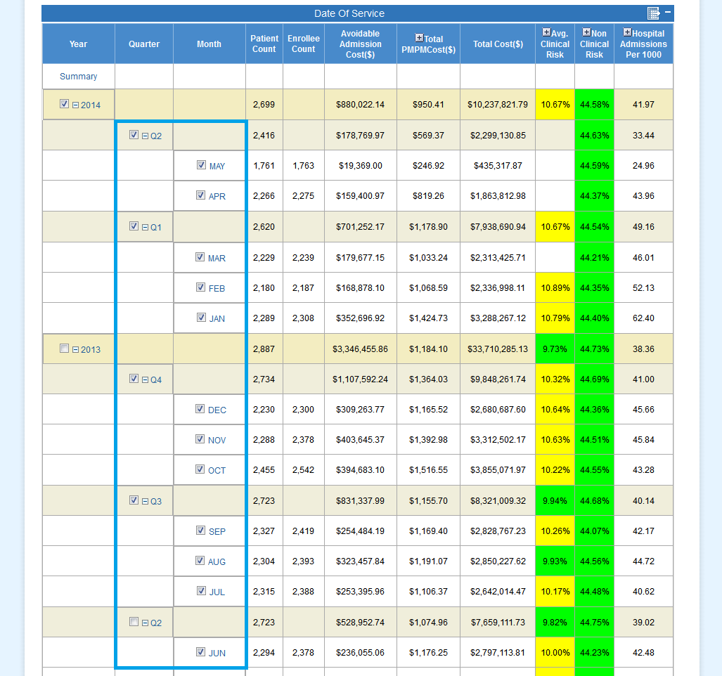

4. Click on Mulitselect.

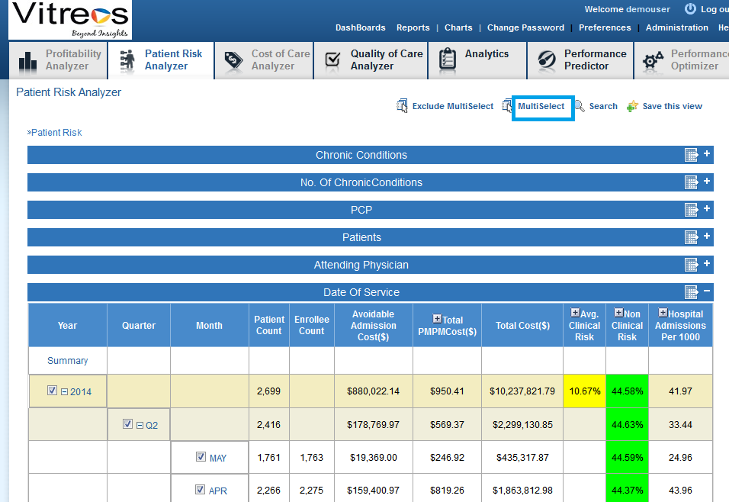

5. Risk analyzer with 1 yr filter is displayed.

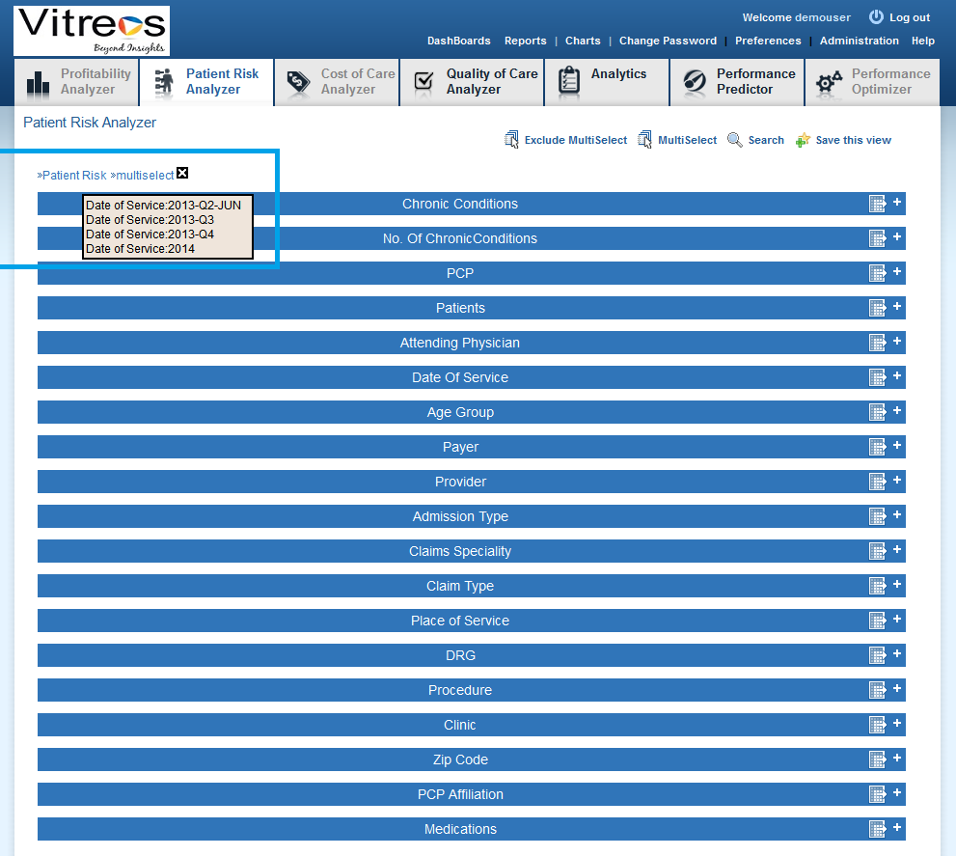

6. Expand All dimensions.

7. Check all dimensions are expanded without any error.

**Test Cases# 4** - Verify that user is able to export the Disparities report with 1 yr filter.

1. Open Risk Analyzer.

2. Click on Date of Service Dimension.

3. select the recent 12 months check boxes.

4. Click on Mulitselect.

5. Risk analyzer with 1 yr filter is displayed.

6. Expand Patient Dimension.

7. Mouse hover over export filter link.

8. Select the option mentioned in below screen shot.

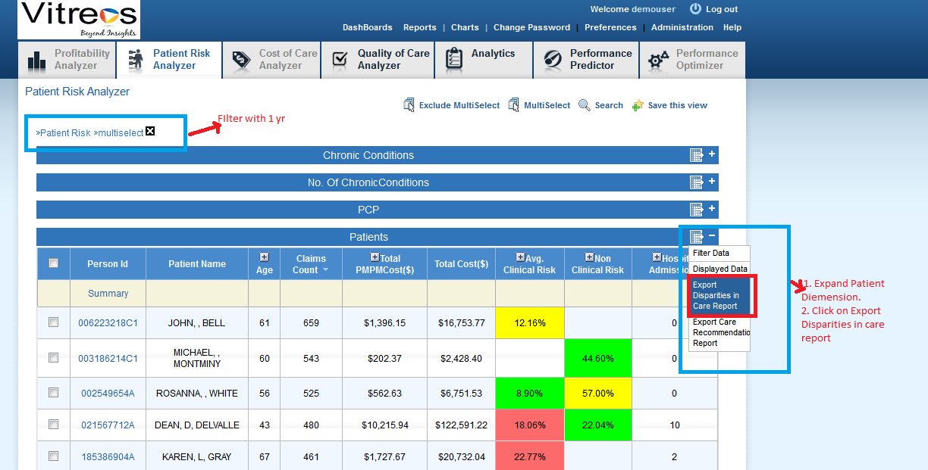

9. A pop up with radio button and check box options are displayed. Select the options highlighted in the below screen shot and click on Generate Report button.

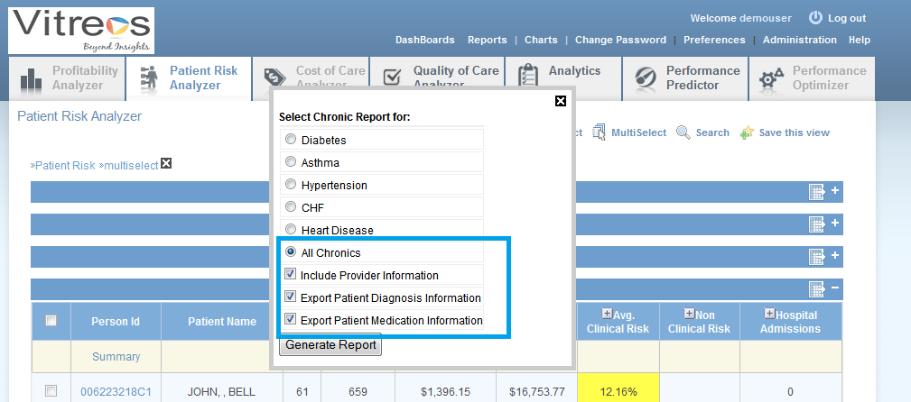

10. The page displayed in below screen shot is displayed. Click on Export to Xls link as highlighted in below and make sure the reported is exported in xls format.

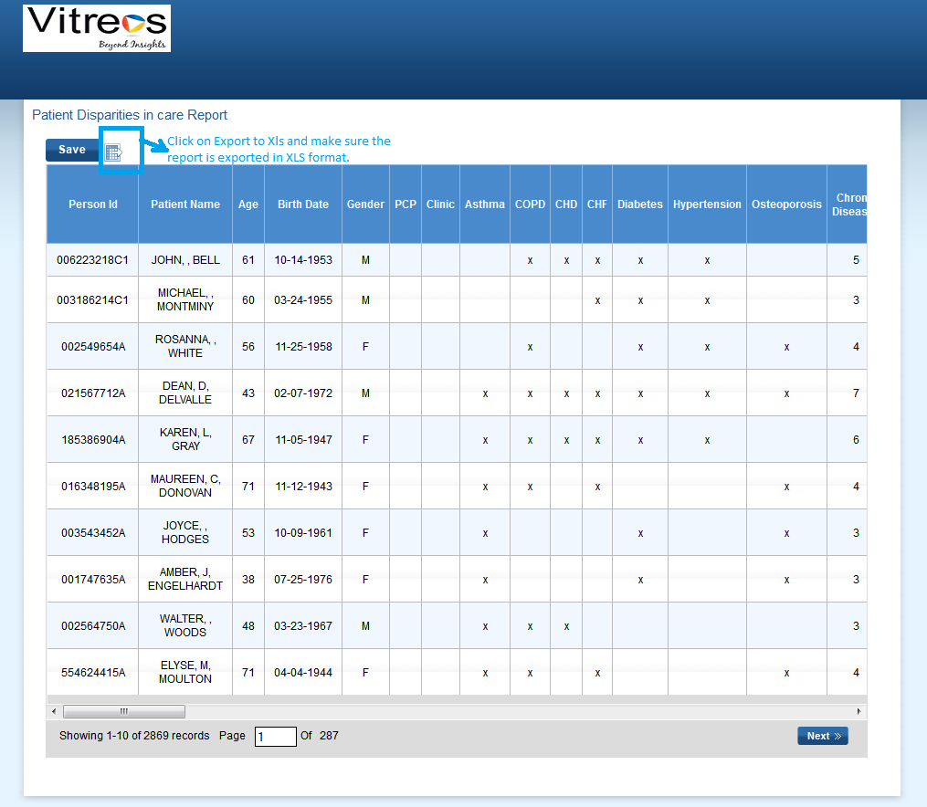

**Test Cases# 5:** - Verify that user is able to export the Care Recommendation report with 1 yr filter.

1. Open Risk Analyser.

2. Click on Date of Service Dimension.

3. select the recent 12 months check boxes.

4. Click on Mulitselect.

5. Risk analyzer with 1 yr filter is displayed.

6. Expand Patient Diemension.

7. Mouse hover over export filter link.

8. Select the option ‘Export care recommendation report’ .

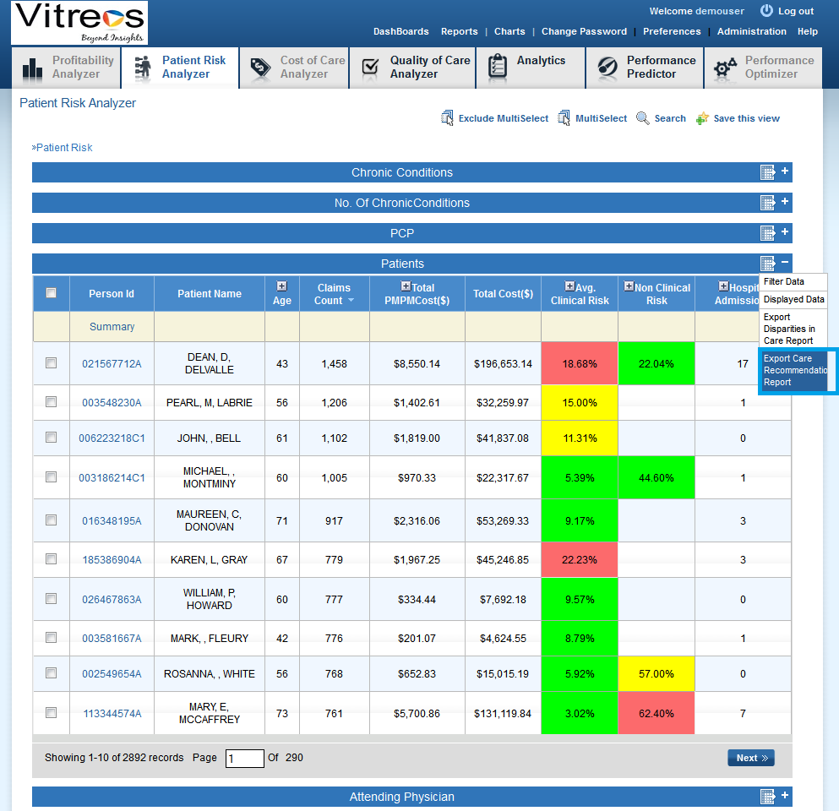

9. A pop up with radio button and check box options are displayed.

10. Select the option "All chronics" and all the 3 check boxes and click on Generate Report button.

11. Patient care recommendation report page is displayed.

12. Click on Export to xls link and check that report is exported in xls format.

**Test Cases# 6**- Verify the "Exclude MultiSelect" functionality.

1. Open Risk analyzer

2. Click on payer Dim

3. Select the check box displayed at header section of Payer Dim.

4. All the check boxes for all the payer are selected as displayed in below screen shot.

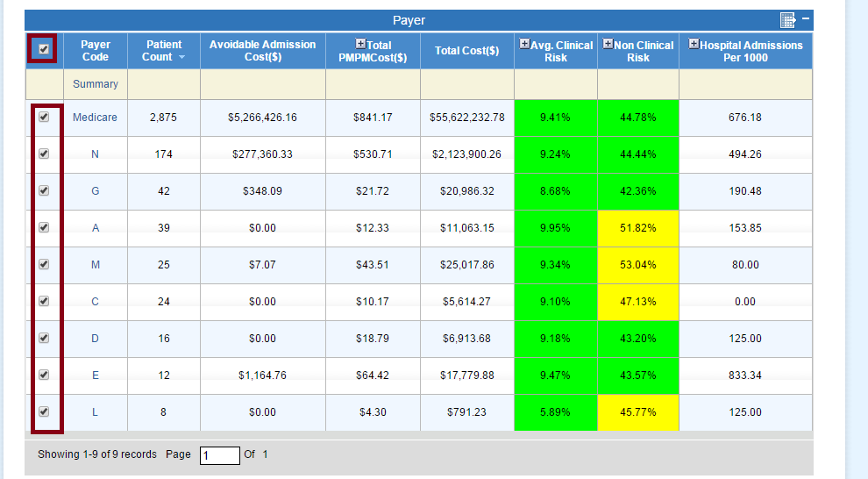

5. Uncheck any two check boxes as displayed in below screen shot.

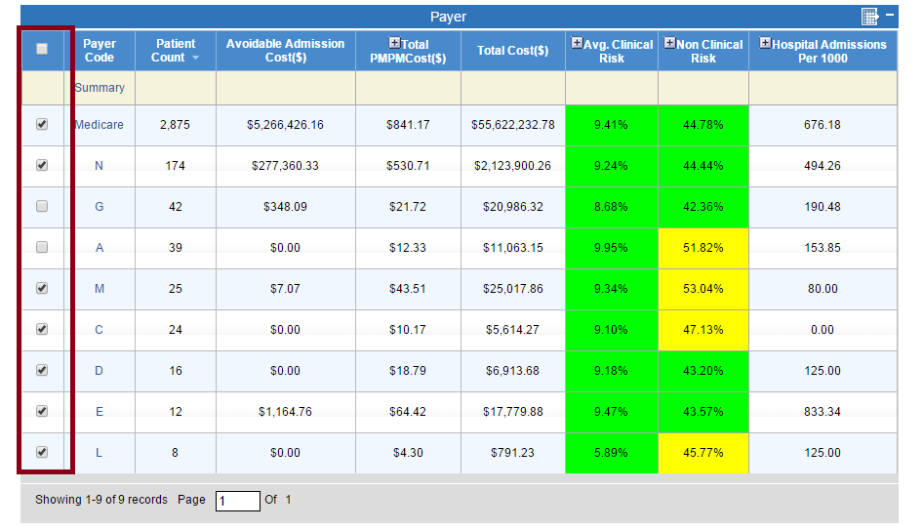

6. Click on "Exclude MultiSelect".

7. Risk Analyzer with selected filter is displayed.333

8. Click on Payer Dim.33

9. Check that unselected payer's are only displayed in Payer Dim as displayed in below screen shot.

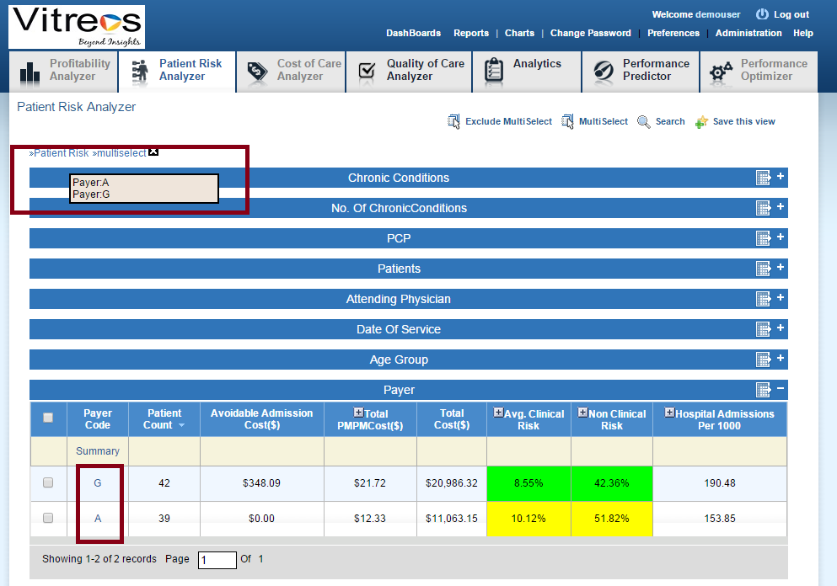

**Test Cases# 7 – Search for Patient information**

1. Open Risk Analyser.

2. click on Search link and navigate to search page.

3. Select the options:

Dimension -> Patients

Atrribute -> Patient name

Filter -> contains

Criteria -> <any patient name- eg: thomas>

Radio button -> any is selected

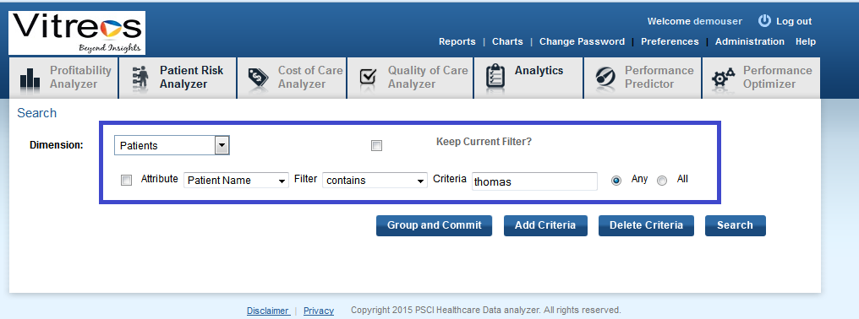

4. Click group and Commit button.

5. Search query is displayed in the Text box.

6. Click on Search button.

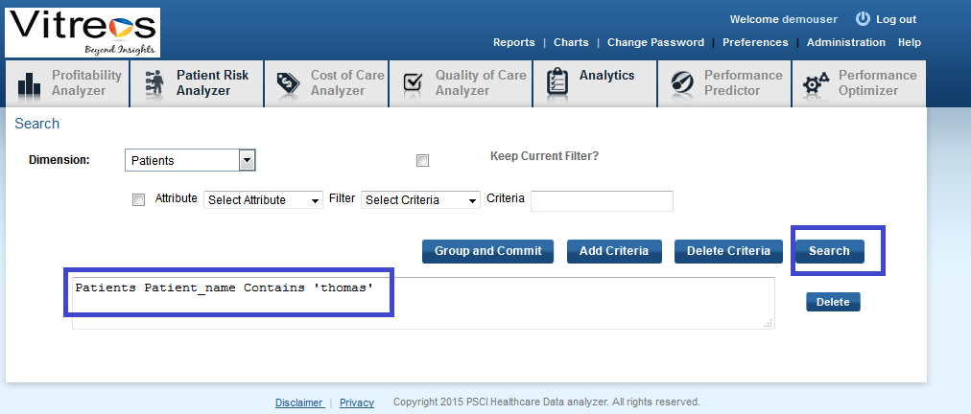

7. Appropriate search results are displayed.

8. Select the check box "select / Unselect all the members".

9. All the search results are selected.

10. click on Apply button.

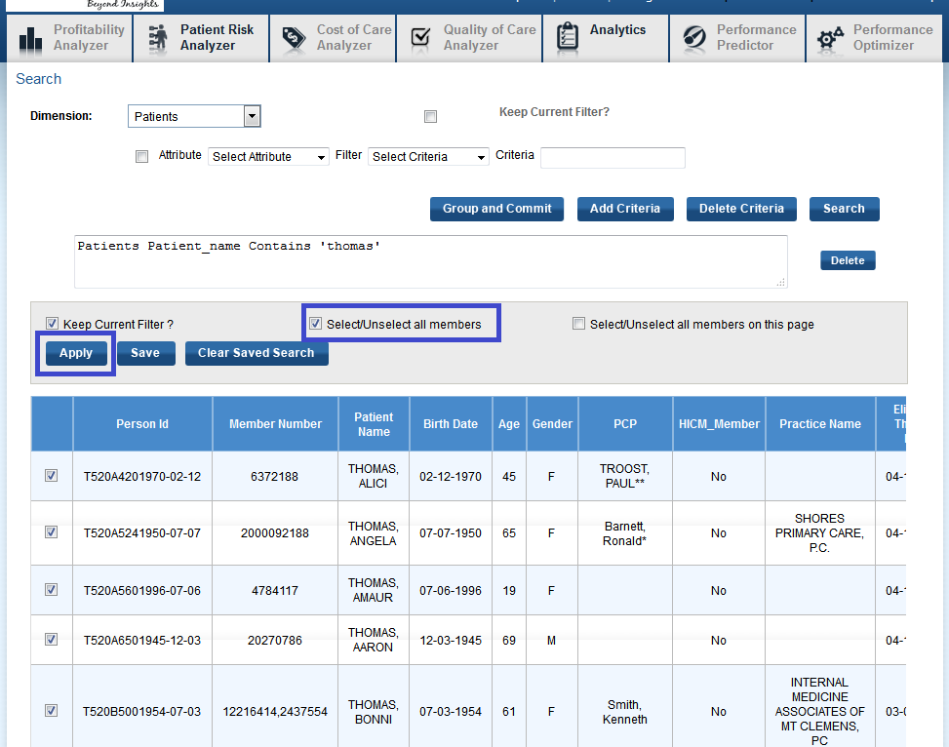

11. Risk Analyzer with search results is displayed.

12. Click on patients Dimension

13. Check that the patients names contains the text "thomas".

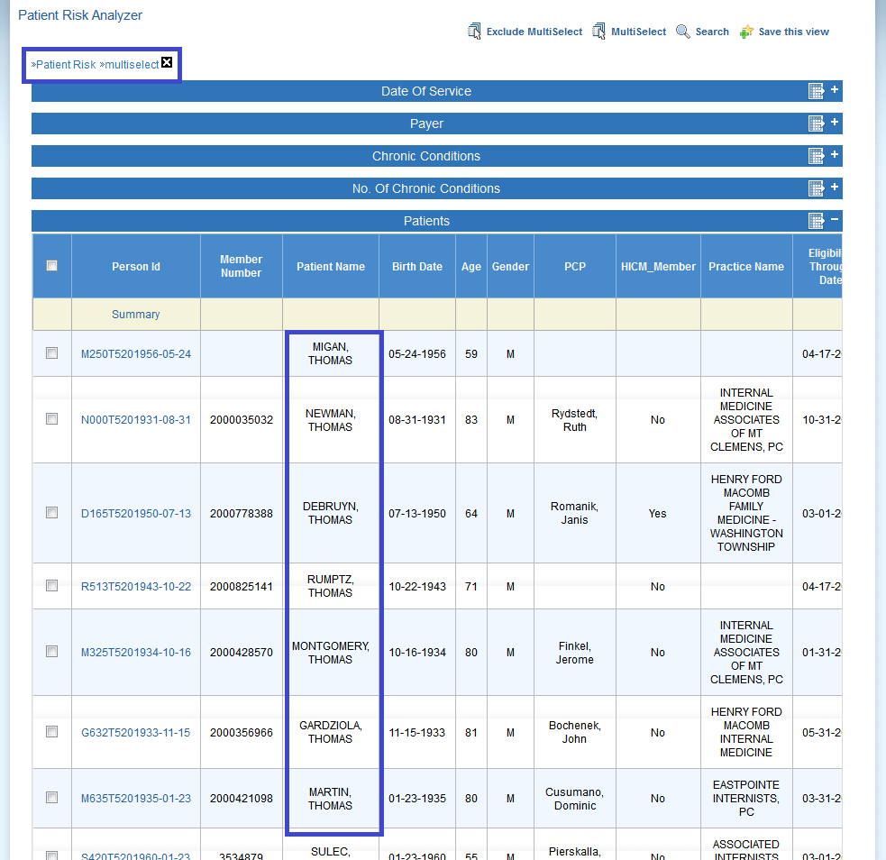

**Test Cases# 8:** Verify the "MultiSelect" functionality

1. Open Risk analyzer

2. Click on PCP Dim

3. Select few check boxes from PCP Dim.

4. Click on "MultiSelect".

5. Risk Analyzer with selected filter is displayed.

6. Click on PCP Dim.

7. Check that only Selected PCP's are displayed in PCP Dim.

**Test case: 9** - Verify the "Analytics" functionality.

1. Open Risk analyzer.

2. Click Analytics tab and go to Analytics page.

3. From Analytics tab, select the following options from drop down:

Dimension --> Patients

Whose --> risk --> HCC risk

Criteria-->  greater than

Enter criteria --> 2

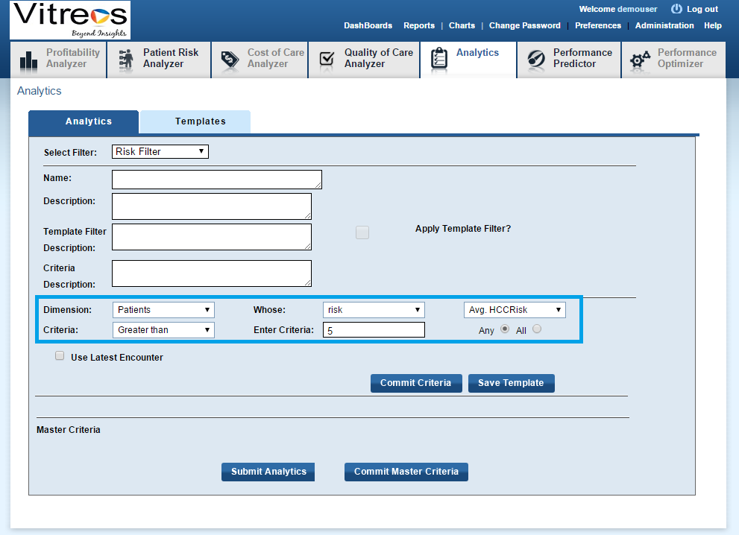

4. Click on commit criteria button

5. Condition is displayed in the text box as displayed in screen shot

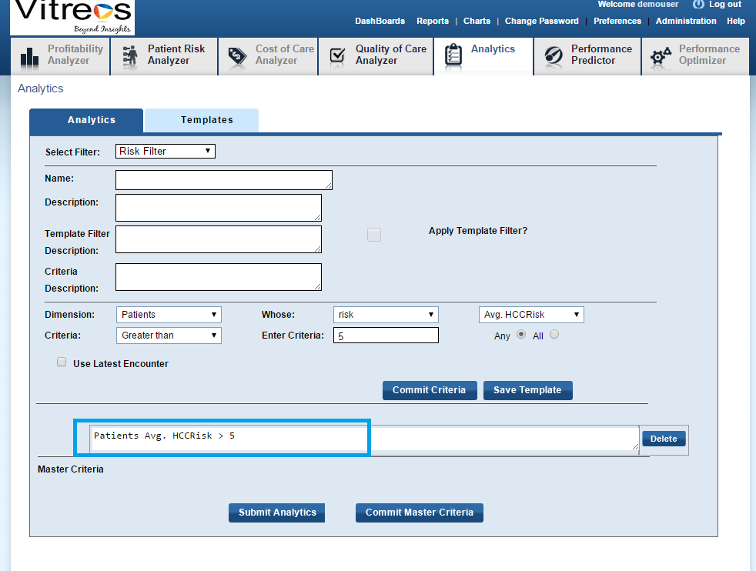

6. Click on 'commit master criteria' button.

7. Condition is displayed at master criteria text box as displayed in screen shot.

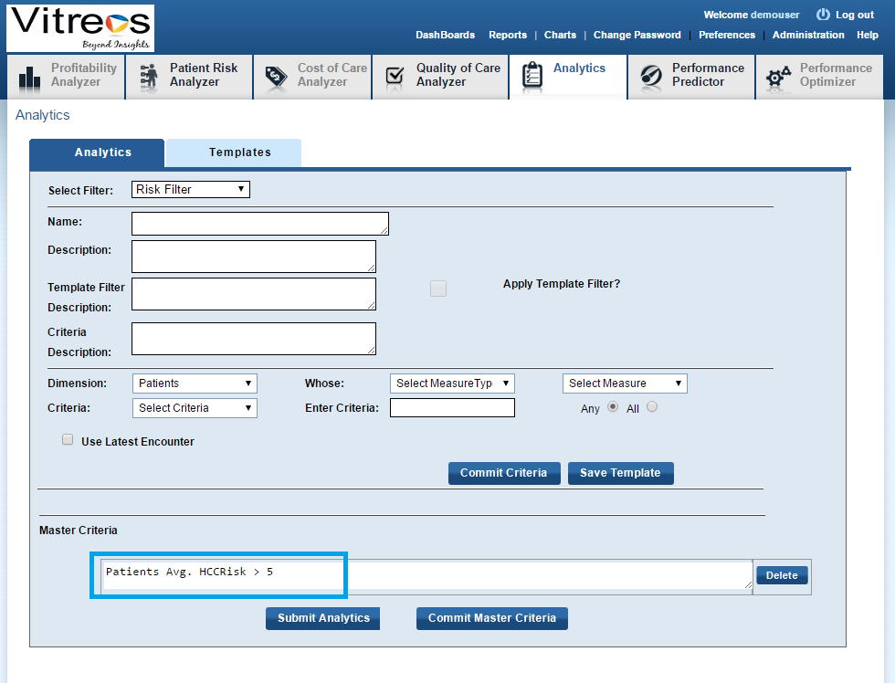

8. Click on 'Submit Analytics' button.

9. A pop up is displayed and click ok.

10 the results are displayed in a box as displayed in the screen shot.

11. Select all results by clicking on the check box displayed at header.

12. Click on apply button.

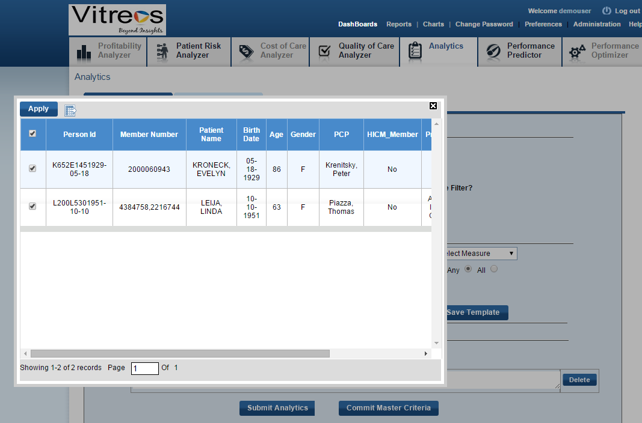

                13. Risk analyzer page is displayed with filter.

                14. Click on patients Dimension.

                15. Click on + symbol displayed at Avg. clinical risk and make sure it is expanded.

                16. Check that HCC Risk value displayed greater than 2.

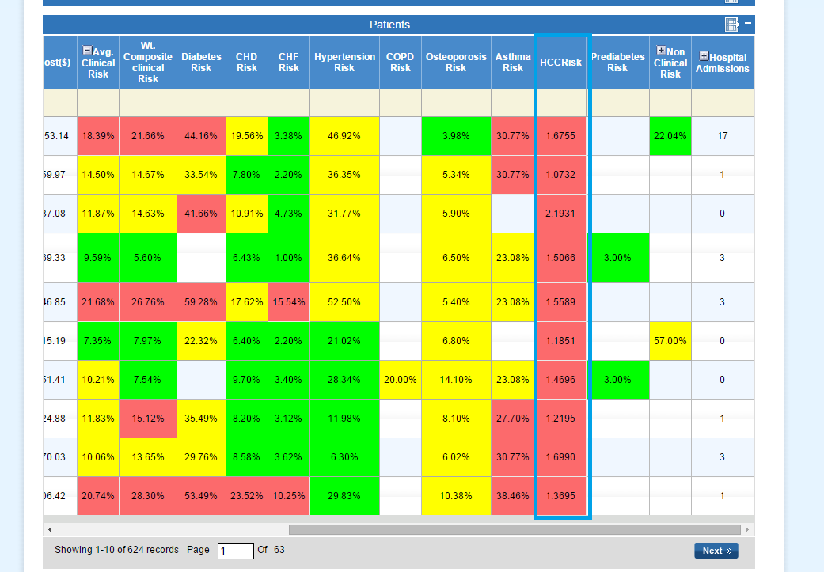

**Test case 10** merged into one scenario as Test case 10: Verify the reports functionality - Creating and view and access

1. Open Risk Analyser.

2. Click on Date of Service Dimension.

3. select the recent 12 months check boxes.

4. Click on Mulitselect.

5. Risk analyzer with 1 yr filter is displayed.

6. Click on "save this View" link .

7. Save this View page is displayed.

8. Enter View Name and click on 'Create View' Button.

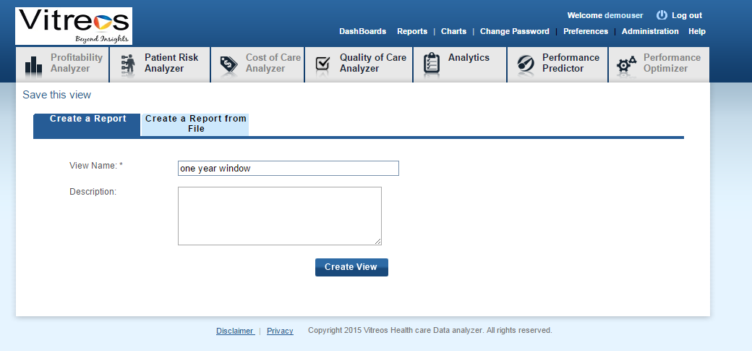

9. View Successfully created message is displayed in the same page.

10. Click on Reports Link and go to Reports page.

11. created view is displayed in the reports page(As displayed in screen Shot).

12. Click on it and make sure that User is navigated to risk analyzer page with one year filter.

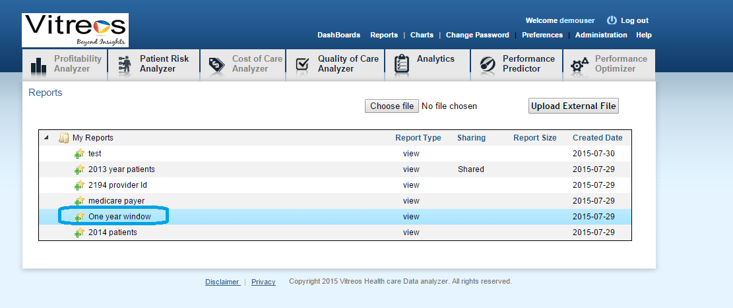

**Test case 11:** Verify that user is able to open all charts. (Modified the test case Title.)

1. Open Risk analyzer.

2. Click on Charts links displayed at header section.

3. Select chart type as 'SOH Chart' and click on Submit button and make sure graph is generated.

4. Select Chart Type - 'Geo Spatical chart' and click update Map, make sure graph is generated.

5. Select chart Type Pareto chart and click on submit button.

6. Go on Selecting each chart Type and click on submit button with the default options displayed in drop downs and make sure graphs are generated for each chart Type.

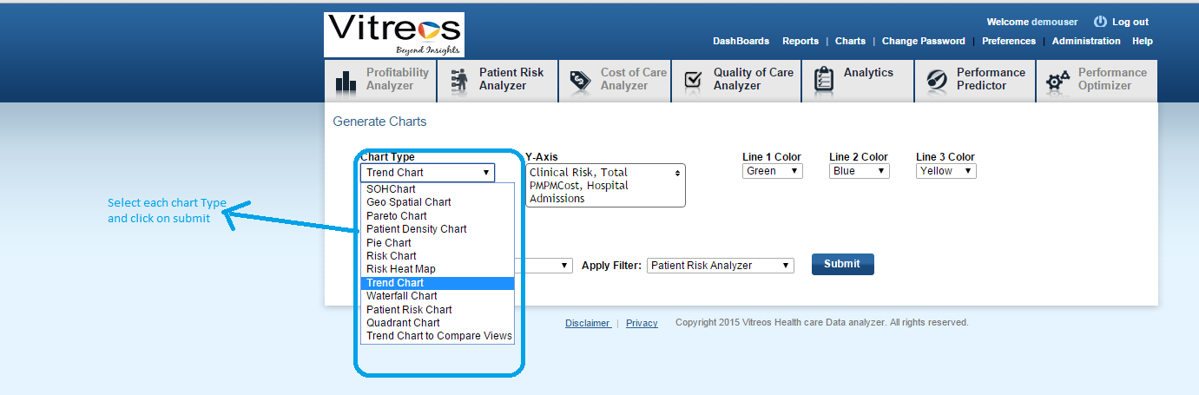

**Test case 12:** Verify the PMPM cost for 2015 - Q2 from DOS Dimension

**Steps to reproduce;**

1. Open Risk analyzer.

2. Click on DOS Dimension.

3. Expand 2015 --> Expand Q2

4. Check that the total PMPM cost displayed correctly for Q2 ( displayed in screen shot).

: Total PMPM cost Formulae – Total cost/Sum( Enrollee Counts in the months)

eg:   165,690,900.75 / (178,655+ 75,985+79,172) = 496.36 (Round of the value and display in application)

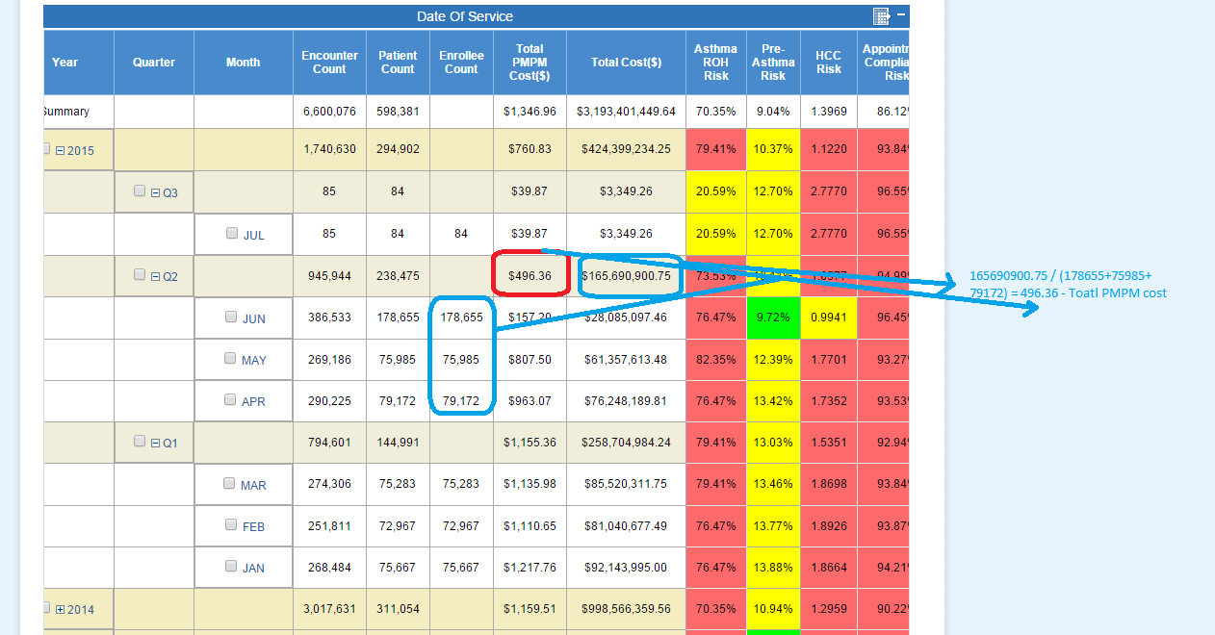

**Test case 13:** Verify the rate measures values (Hospital admission per 1000, per admission per 100, Er visits per 1000) for 2015 - Q2 from DOS Dimension

**Steps to reproduce:**

1. Open Risk analyzer.

2. Click on DOS Dimension.

3. Expand 2015 --> Expand Q2

4. Check that the Hospital Admissions Per 1000 displayed correctly for Q2 ( displayed in screen shot).

Formulae: (sum(admission count)/average of months enrollee count for that quarter) * 1000

To get the value for sum of admission count, mouse over on Hospital Admissions Per 1000 for Q2 as displayed in screen shot (tool tips value 3743)

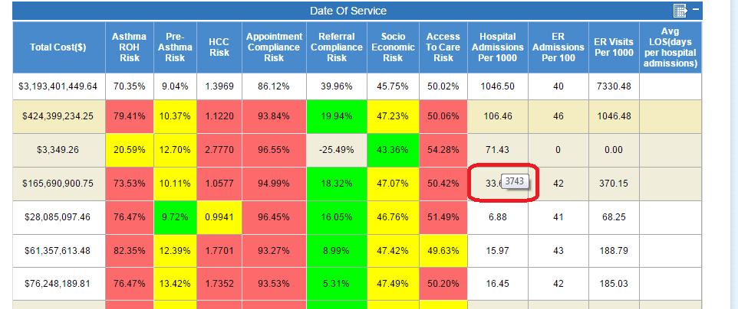

average of months enrollee count for that quarter =  (178655+75985+79172) / 3 = 111270.67

Formulae  = (3743 /111270.67) * 1000 = 33.63869 (rounded to 33.64 which is displayed in application)

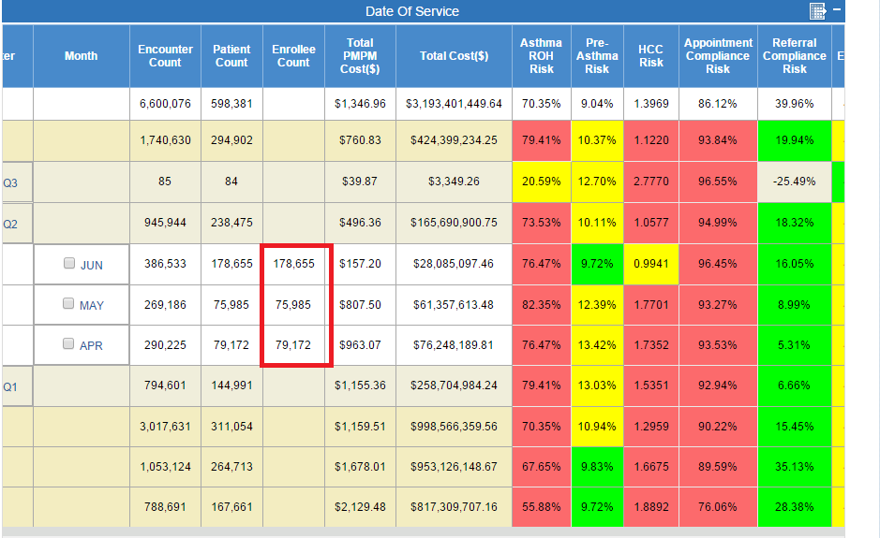

**Pending part of TC-13**

5. Check ER Admissions Per 100 value is displayed for Q2

Formulae : (er_admissions/Hosp_Admissions)*100

Hosp_Admissions = Mouse over on the cell for Hospital Admissions Per 1000 for Q2 – 3743

er_admission = Mouse over on the cell for ER Admissions Per 100 for Q2 – 1554 (See below Screen shot )

Formulae = (1554 / 3743) * 100 = 42 which is displayed in Application.

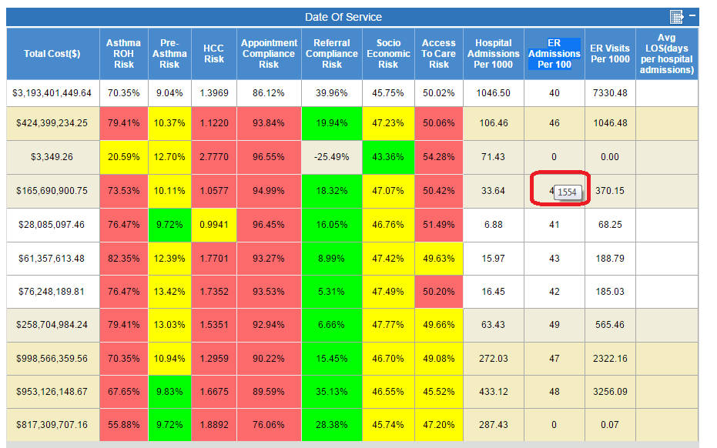

6.  Check ER Visits Per 1000 value  displayed for Q2

Formulae: [sum(ER_visits)/average of months enrollee count for that quarter] * 1000.

To get the value for sum of visit count, mouse over on the cell under  ER Visits Per 1000 displayed for Q2 as displayed in screen shot below (41186)

average of months enrollee count for that quarter =  (178655+75985+79172) / 3 = 111270.67

(41186 / 111270.67) * 1000 = 370.14246 (rounded to 370.15 and displayed in application)

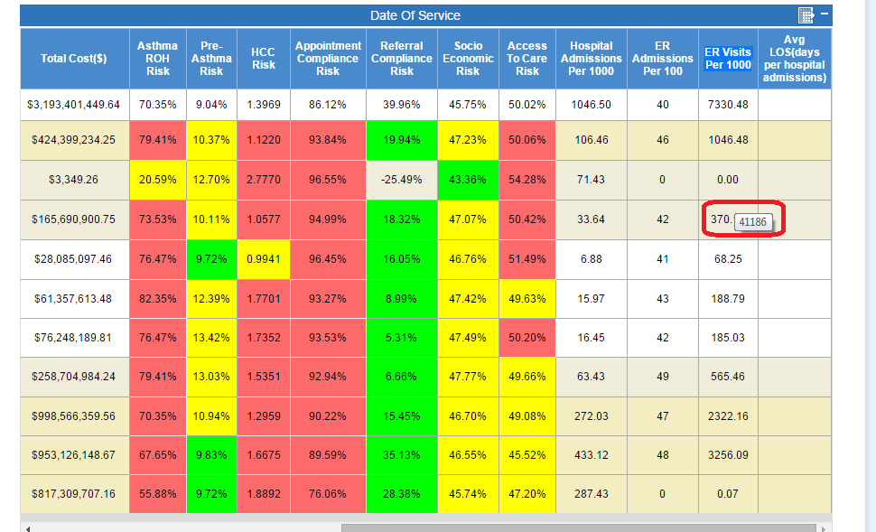

14. Test case. Verify the Trend chart values with respect to time dimension.  
Steps:  
1. Open RA  
2. Click on Charts Links and Go to charts page.  
3. Generate Trend Chart.  
4. Chart displays some values for the Y-Axis.

5.  Compare the values with the time dimension as displayed in Screen shot.

